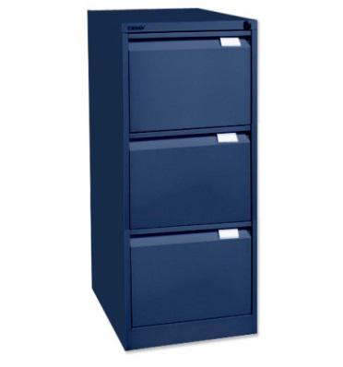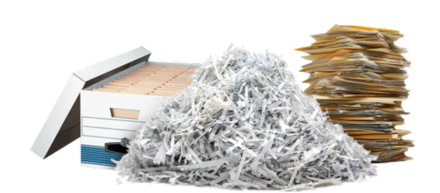
GDPR Data Protection Regulation has been updated to give individuals greater powers to name, shame & be compensated if privacy is invaded
After scandalous sales of personal information, both Public & private Business & organisations are expected to treat individuals details with great care, also being obliged to destroy all redundant, out dated records, meaning that information stored about staff, suppliers & accounts details must be securely destroyed, rather than stored away. The Information Commission Office which regulates business & organisations are imposing significant Fines to non compliant operations. We have some suggestions that could help your Compliance.
6 Tips that will save you money when destroying archived Confidential information
Select a reputable shredding service provider, ideally recommended from a colleague, local Chamber of Commerce, or your Industry. A credible company will send a Fact file including all License details, send an assessor to audit your data, recommend the most appropriate service for your needs & send an accurate quotation.
Sacks are appropriate for clearing data from areas with restricted access such as Basements or Upper floors. As a general guideline, 1 x 10 kilo industry standard sack will contain the contents from 1 drawer of a filing cabinet & 2 sacks will contain 1 metre of shelved files.
Wheeled bins may be better when clearing shelving from an area that has level access from collection vehicle. As a guideline, 1 x 340 litre wheeled bin can contain 2 m shelved data, 1 x 660 ltr bin can contain up to 4 metres of files / wallets.(c15 boxes)
In summary, you can negotiate & reduce service costs by;
1. Requesting sacks or bins in advance. Agreeing delivery & collection dates when service provider is already operating in your area is environmentally friendly & saves transport costs.
2. Preparing papers for shredding. If you expect your shredded paper to be recycled remove plastic pockets, folders & wallets. No need to waste your time removing staples, paperclips or card dividers. Filling containers yourself, emptying papers from ring binders will reduce wasted space, prepare list of sack tag numbers. X marking Boxes clearly identifies data to be destroyed Avoid overfilling bins or bags as heavy sacks cannot be Safety lifted, & over weight bins that are difficult to move may not be safe to transport.
3. Stacking data as close to access as you can. Organise vehicle parking place for the day of collection.
4. Proposing to work with your preferred shredding company again. Improve security by buying or hiring a locking confidential waste container for your office & committing to a service schedule.
5. Agreeing payment within 14 days could encourage a saving.
6. Asking for a discount if you hold charitable/ Social enterprise status.
Citrus secure shredding have managed hundreds of archive destruction Projects, & are committed to ISO Certificate 27001: 2013 Information Technology, Security Techniques, Information Security Management Systems Standard.
For best advice visit The Information Commissioner’s Office guide on; https://ico.org.uk/for-organisations/guide-to-data-protection/principle-5-retention/
Weeding out confidential data that is no longer relevant from archives & on electronic storage is not only a good business practice, but is also a Legal requirement.

